`Software Specifications Document (SSD)
New Entity

Profile
Title | Aria Email
Tracking # | ?????
Product Line | X Aria4Xp
Module(s) | System Manager
Entity Type
Customer | Aria Systems
Date Created | 03 /02 /2010
Author | Hassan
Date Edited | MM / DD / YYYY
Editor
Analysis | Approved By
Analysis | Approval Date |  | MM / DD / YYYY
Conceptual Design | Approved By
Conceptual Design | Approval Date |  | MM / DD / YYYY
Detailed Design | Approved By
Detailed Design | Approval Date |  | MM / DD / YYYY

Table of Contents
Profile 1
Table of Contents 2
Document Sections 3
Versions 4
PART I – Business Analysis 5
Vision 5
Stakeholders 5
Needs 6
CFN – Customer Functional Needs 6
CTC – Customer Technical Needs Error! Bookmark not defined.
AFN – Aria Functional Needs Error! Bookmark not defined.
ATC – Aria Technical Needs Error! Bookmark not defined.
ATT – Aria Testing Needs Error! Bookmark not defined.
AMT – Aria Marketing Needs Error! Bookmark not defined.
ADT – Aria Documentation Needs Error! Bookmark not defined.
AST – Aria Supplementary Needs Error! Bookmark not defined.
Project Scope Error! Bookmark not defined.
1. In/Out Domains Error! Bookmark not defined.
2. Project Phases Error! Bookmark not defined.
Assumptions Error! Bookmark not defined.
Glossary Error! Bookmark not defined.
PART II – Solution Proposal Error! Bookmark not defined.
Approach Error! Bookmark not defined.
Solution Overview Error! Bookmark not defined.
Business Cases Error! Bookmark not defined.
Required Entities Summary Error! Bookmark not defined.
PART III – Conceptual Design Error! Bookmark not defined.
Parent Modules Error! Bookmark not defined.
Entity Features Error! Bookmark not defined.
User Interface (UI) Error! Bookmark not defined.
Option Grid Error! Bookmark not defined.
Use Cases Error! Bookmark not defined.
PART IV – Detailed Design Error! Bookmark not defined.
UI Rules Error! Bookmark not defined.
Option Grid Rules Error! Bookmark not defined.
Application Tier Error! Bookmark not defined.
Database Design Error! Bookmark not defined.
Testing Cases Error! Bookmark not defined.

Document Sections
Analysis
Vision
Stakeholders
Needs *
Customer Functional Needs
Customer Technical Needs
Aria Functional Needs
Aria Technical Needs
Aria Testing Needs
Aria Marketing Needs
Aria Documentation Needs
Supplementary Needs
Project Scope
Assumptions
Glossary
Solution Proposal
Approach
Solution Overview
Business Cases
Required Entities Summary
Conceptual Design
Parent Modules
Entity Features
User Interface (UI)
Option Grid
Use Cases
Detailed Design
UI Rules
Option Grid Rules
Application Tier
Database Design
Testing Cases

Versions
VER # | Date | Modified By | Sections Change Tracking
VER # | Date | Modified By | New | Deleted | Changed
0.1 | 03/02/2009 | Ahmed Maher | Ahmed Maher
0.2
0.3
0.4
0.5
0.6
0.7

PART I – Business Analysis

Vision

Stakeholders
Role | Category | Description | Comments
Aria Systems | Aria | Aria Systems

Needs

CFN – Customer Functional Needs

ATN – Aria Technical Needs
The following are the technical needs related to developing this program:

- Modified Client Tool (Distribution Tool)
      - Modify screen to enable from enter (Server name, database name, user ID and password).
      - Create client master database.
      - Updates all insert statement related insert record into Clients table (For all updating of Clients table).
      - Create an XML file (under the client folder) where Contain the following information's:
  - Storing client ID
  - Connection information to his master database.
- Remove the email setting information from the CLIENT table
- Modify CLIENTS table in SYSTEM.MASTER:
      - Add the following fields to table to store client master database connection information:
      - CCONSERVER C(64)
      - CCONDBNAME C(128)
      - CCONUSERID C(128)
      - CCONPASWRD C(10)
- Aria configuration screen will be modified when running under SaaS environment:
      - Email setting screen will handle information of email specific of Aria not client.
      - Modify Database setting screen to attach SYSTEM.MASTER Database only.
      - Hide Row Client database name (In SAAS) in Database setting screen.
- Modify Client Master Database:
      - Add new table call SETTINGS where contain the following fields:
- SMTPSERVER VARCHAR(30)
- SMTPPORT INT
- SMTPUSERNAME VARCHAR(50)
- SMTPUSERPASSWORD VARCHAR(20)
- SENDERNAME VARCHAR(30)
- SSL Bit

- Modify AriaEnvironment DLL:
      - Get Client ID from XML Located in "X:\".
      - Modify DLL to read information from Clients Table locate in System Master Database to enable from generate connection string.
- Modify ARIAMESSAGINGMANAGER Class:
      - Modify Class to combatable with modification applied on AriaEnvironment DLL.
      - Create Send Email method (overwrite the found one) to support send email (To, Cc, Bcc) and attach files (collecting information depend on Client saved Client Database).
      - Create Send Email method (overwrite previous created method) as the following data added by user.
      - SMTPUSERNAME
      - SMTPUSERPASSWORD
      - SENDERNAME

Required Entities Summary

Entity # | Required entity title | Need(s) satisfied | Tracking #
13 | Modify AriaEnvironment DLL | 2.7
14 | Create Email Setting web page | 8

Entity # 1: Modified Client Tool (Distribution Tool)

Data Item | Include Status | Contents
Entity # | Yes | 1
Name | Yes | Modified Client Tool
Type | Yes | New
Module(s) | Yes
Tracking # | Yes
Features | Yes
UI | No
UI rules | No
Database design | No
Testing cases | Yes
Needs satisfied | Yes | 8

Features:
- Modify the UI of Screen to support the following information's:
      - Server name: That contain Client master DB
      - Database name: name of Database refer to Client DB.
      - User Name and Password.
- Create client master database:
      - Add user already created to be owner and if Database on other server (not 178) create this user and add as owner.
      - Create database by generated script not attach.
- Updates all insert statement related insert record into Clients table (For all updating of Clients table).
- Create XML File call <Cleint_Setting.XML> contain Client ID saved in Path of client folder as \\Shared\<ClientID>\
      - Structure of XML as the following :
<?xml version="1.0" encoding="utf-8"?>
<DocumentElement>
<ClientConfig>
<ClientID>BRI10</ClientID>
</ ClientConfig >
</DocumentElement>
- Create .Net documentation to code for all Modified code and created code.

Entity # 3: Create Class to mange Clients Table

Data Item | Include Status | Contents
Entity # | Yes | 7
Name | Yes | Create Class to mange Clients Table
Type | Yes | New
Module(s) | Yes
Tracking # | Yes
Features | Yes
UI | No
UI rules | No
Database design | No
Testing cases | Yes | 4
Needs satisfied | Yes | 8

Features:
- Create Class Diagram for this project….
- Create .Net documentation for code…
- Create Sequence Diagram….
- Create .net project contain all mange working with system master database call ARIADATAACCESSLAYER
- Create class call represent Data access layer.
- Create new class in the last project call AriaClient to manage the following feature:
- Add new Client (insert data in Clients table)
- Update Client
- Delete
- Retrieving data by CCLIENTID
- Create doc for all methods and properties in this project….

Entity # 4: Modify AriaEnvironment DLL

Data Item | Include Status | Contents
Entity # | Yes | 7
Name | Yes | Create Modify AriaEnvironment DLL
Type | Yes | New
Module(s) | Yes
Tracking # | Yes
Features | Yes
UI | No
UI rules | No
Database design | No
Testing cases | Yes | 4
Needs satisfied | Yes | 8

Features:
- Create Class Diagram for this project….
- Create .Net documentation for code …
- Create Sequence Diagram.
- Create new property call ClientDatabaseConnectionString and ClientDatabaseConnectionStringODBC where get connection from AriaClientDBConnection.
- Create new method call GetClientID used to get client id from Path of Client.
- Create method call AriaClientDBConnection (string ClientID): used to generate connect to System.Master DB and get information related to client DB and generate connection string and fill property call ClientDatabaseConnectionString.
- Create doc for all methods and properties in this project.
- Collect all information in one Doc….

Entity # 5: ARIAMESSAGINGMANAGER Class

Data Item | Include Status | Contents
Entity # | Yes | 7
Name | Yes | ARIAMESSAGINGMANAGER Class
Type | Yes | New
Module(s) | Yes
Tracking # | Yes
Features | Yes
UI | No
UI rules | No
Database design | No
Testing cases | Yes | 4
Needs satisfied | Yes | 8
      - Create Send Email method (overwrite the found one) to support send email (To, Cc, Bcc) and attach files (collecting information depend on Client saved Client Database).
      - Create Send Email method (overwrite previous created method) as the following data added by user.
      - SMTPUSERNAME
      - SMTPUSERPASSWORD
      - SENDERNAME
Features:
- Create Class Diagram for this project ….
- Create .Net documentation for code …
- Create Sequence Diagram….
- Create Send Email method (overwrite the found one) to support send email (To, Cc, Bcc) and attach files (collecting information depend on Client saved Client Database). Call Aria4SendEmail
- Create new method call ReleaseObj used to Release object after send email to release files that attach to enable from try use this files.
- Sending email must support SSL(True or false).
- Must support to send body as HTML.
- Must enable us from get error message if send fail.
- Collect all information in one Doc….

Entity # 8: Create web page call Email setting:

Data Item | Include Status | Contents
Entity # | Yes | 8
Name | Yes | Create web page call Email setting:
Type | Yes | New
Module(s) | Yes
Tracking # | Yes
Features | Yes
UI | Yes
UI rules | Yes
Database design | No
Testing cases | Yes | 6
Needs satisfied | Yes | 8
      - This page read client id from logged in Client id from ariaonline web site.
      - It's get client master database connection from system master database by client id.
      - It's enable client from add, edit and delete email setting from SETTINGS table from client master database.
Features:
- Must be support tab to enable from increase it in future.
- Support task pane

UI:
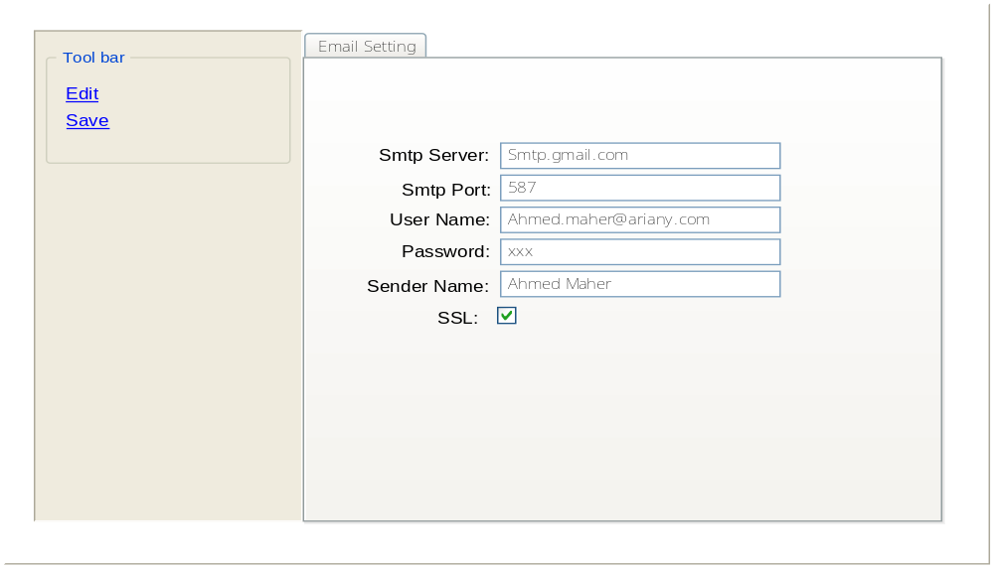

UI rules:
- Textbox specific smtp server must be not increase on 30 char.
- Textbox specific smtp port must be number only.
- Textbox specific user name not increase on 50 char and validate on email format.
- Textbox specific Password must not increase on 20 char.
- Textbox specific sender name must not increase on 30 char.

Test Case # | 1
Name | Modified Client Tool (Distribution Tool)
Outcome | Create new XML file and <Client>. Master DB
Step # | Action | Value Used
1 | 1. Open Distribution Tool  2. Fill information of this client1  3. Leaves Client Database Setup is empty.  4. and click Execute
Step Outcome | In Created path under D:\Shared\ must found XML file call Cleint_Setting.XML and in sql server found <Client >. Master DB will created

Test Case # | 2
Name | Modified Client Tool (Distribution Tool)
Outcome | Check result information
Step # | Action | Value Used
1 | 1. Open XML file generated previews path  2. check if client id saved  3. login on SQL server by created user where username: first three char from Client id and pass: first three+ Phone number  4. try to edit in db.
Step Outcome | Check result information

Test Case # | 3
Name | How Get client Id.
Outcome | Return CLIENTID and Client db Connection information.
Step # | Action | Value Used
1 | 1. Create object from Aria.Environment. AriaEnviromentVariables and call method GetClientID() which return clientid as string.  2. Create object from Aria.Environment. AriaEnviromentVariables and call property ClientDatabaseConnectionString, this property enable us from connect to DB by .net.  3. Create object from Aria.Environment. AriaEnviromentVariables and call property ClientDatabaseConnectionStringODBC , this property enable us from connect to DB by ODBC.
Step Outcome | Return CLIENTID and Client db Connection information.

Test Case # | 4
Name | Send Email.
Outcome | Send email by using To,CC,Bcc and attach.
Step # | Action | Value Used
1 | 1. Create object from Aria.EnterpriseServices.Messaging. AriaMessagingManager and call method Aria4SendEmail <to enable from use it please Go to this DOC>.  2. to check error please Check <objectName>.Error if true check <objectName>.ErrorMessage else check your emails must send.  3. check for sending many email in same environment and to forget use method call ReleaseObj() .
Step Outcome | Send email by using To,CC,Bcc and attach.

Test Case # | 5
Name | Working with Clients table using Aria.DataAccessLayer
Outcome | Retrieving, update, delete and insert.
Step # | Action | Value Used
1 | 1. Create object from Aria.DataAccessLayer. SystemDB. AriaClient and call methods that enable us from managing Clients table <to enable from use it please Go to this DOC>.
Step Outcome | Retrieving, update, delete and insert.

